**Sustainable Supply Chain Performance Dashboard using Power BI**

**Week 1 Task:**

Power BI installation (for windows)

Step 1 − Type "Power BI download" in the Google search engine and click on the first link on the page - [**https://www.microsoft.com/en-us/download/details.aspx?id=58494**](https://www.microsoft.com/en-us/download/details.aspx?id=58494)

Step 2 – Select your preferred language and click on Download



Download the version of Power BI Desktop that matches the architecture (x86 or x64) of your Windows OS.

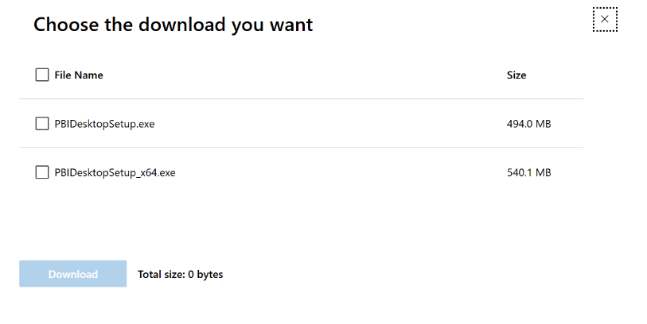

Step 3 – Run the EXE installer and follow the setup steps to finish.

**Using Power BI to Load and Transform Data**

* After installation, Open Power BI Desktop. Click on Blank Report.
* In the Power BI Desktop Window, Select Get Data, from the Data menu, in the Home Tab.
* From the Get Data dropdown menu, Select Text/CSV and select the Sustainable Supply Chain Performance CSV file stored your device.
* A pop-up screen will appear. Click on LOAD.
* Once loaded, we will now TRANSFORM the data. Click on TRANSFORM Data, from the Queries menu, in the Home tab.
* The Power Query Editor will Open. Make sure that the Column Quality checkbox is checked in the View Menu of the Power Query Editor.

**Adding a duplicate table**

Right click on the “Sustainable Supply Chain Performance” table on the left, and click on Duplicate. This will create a Duplicate table.

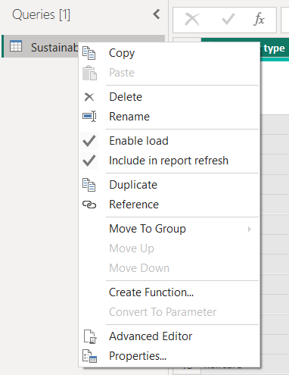

**Inventory Table**

Now, Right click on the Duplicate table and rename it as “Inventory”.

In the Inventory table we only require the following Columns:

1. Product type

2. SKU

3. Availability

4. Number of products sold

5. Customer demographics

6. Stock levels

7. Lead times

8. Order quantities

9. Revenue generated

To acheive this, we remove the columns we DO NOT want.

Simply Right Click on the Columns and Select Remove. To select multiple columns at a time Ctrl + Select and then right click and click on Remove.

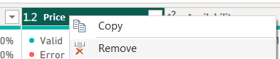

Repeat the same for the other Columns that are not required.

**Manufacturing Table**

Again, Right click on the “Sustainable Supply Chain Performance” table on the left, and click on Duplicate.

Then Right click on this Duplicate table and rename it as “Manufacturing Table”.

In the Manufacturing Table we only require the following Columns:

1. Product type

2. SKU

3. Production volumes

4. Manufacturing lead time

5. Manufacturing costs

6. Inspection results

7. defect rates

Follow the same steps as before to remove the Columns which are not required.

**Supplier Table**

Again, Right click on the “Sustainable Supply Chain Performance” table on the left, and click on Duplicate.

Then Right click on this Duplicate table and rename it as “Supplier Table”.

We only require the following columns for this table:

1. Supplier name

2. Location

3. Lead time

4. transportation modes

5. Routes

Follow the same steps as before to remove the Columns which are not required.

**Supply chain table**

Same as before, Right click on the “Sustainable Supply Chain Performance” table on the left, and click on Duplicate.

Then Right click on this Duplicate table and rename it as “Supply Chain Table”.

1. Product type

2. SKU

3. Price

4. Availability

5. Number of products sold

6. Revenue generated

7. Customer demographics

8. Stock levels

9. Lead times

10. Order quantities

11. Shipping times

12. Shipping carriers

13. Shopping costs

14. Supplier name

15. Location

16. Lead time

17. Transportation modes

18. Routes

Follow the same steps as before to remove the Columns which are not required.

After this, click on Close & Apply in the Home tab, to apply these changes to the table.

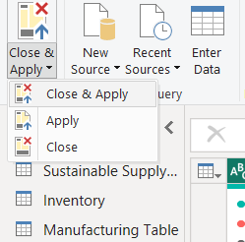

You can now view all these changes in the Model view of the table on the left.

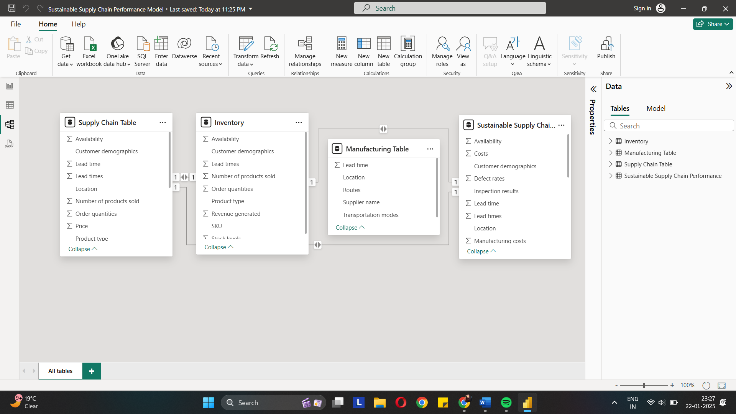

Next, Save your file to your PC.